Calculus Based Physics I: LAB

PHYS 2110 WA

Date: June 3, 2023

Isaac Abella

Experiment 1

Electric Field Mapping

Group:

Isaac Abella

**Objective:**

The objective of this lab is to first: understand the concepts of the electric field-lines and equi-potential, lines, and to second: graph these field-lines based on measured equi-potential lines.

**Equipment:**

A computer with internet access, paper, pencil, and a calculator (ti-84 plus CE/ti 30x II), PHET graphing/laboratory software.

**Theory:**

Electric field lines around a positive point charge are directed ***radially outward.*** The reason is what we have selected as the ***test charge.*** One unit of positive charge is defined as the “***test charge***.” The ***best test charge is the proton itself***. The charge of such test charge is so small that it has no affect on whatever field it is testing upon.

When test charges are placed around a ***positive (+1q) charge,*** then the test charges are repelled away, going ***radially outward.*** Inversely, should test charges be placed around a ***negative (-1q) charge,*** then the test charges will be attracted in, going ***radially inward***

***Equi-potential surfaces*** around ***a single point charge*** are technically spheres centered at the point charge itself. At any point around the equi-potential surface of the sphere, the ***potential*** is the same no matter what. The reason that we refer to it as ***equi-potential*** is that dimensions when drawn in 2 dimensions the ***equi-potential surfaces become equi-potential lines,*** with the spheres becoming circles. The ***radial line/field lines*** are still ***perpendicular*** to all equi-potential surfaces around a point charge.

It can be shown both mathematically and conceptually that regardless of the type of charge distribution, ***field lines are always perpendicular to equi-potential lines.*** This concept may be used to ***find the trajectory of field lines*** around any type of charge distribution ***if equi-potential lines are known.***

Equi-potential lines can be found experimentally by ***using a voltmeter.*** If points around a certain charge distribution can be found to have the same voltage, then it will be possible to connect the points to form a ***equi-potential line.*** Once enough of these lines have been found, then ***field lines*** can be drawn perpendicular to them. This is one of the possible ways to do this in a laboratory setting.

*Two main types of charge distribution that will be used in this experiment are:*

***1) Two equal and opposite point charges (electric dipoles)***

***2) Two equal and opposite parallel surface charges***

***Other charge distributions will also be examined due to capability of the applet at hand.***

**Procedure:**

The Charges and Fields online simulator was opened using the following:

<https://phet.colorado.edu/sims/html/charges-and-fields/latest/charges-and-fields_en.html> . This simulator provides a grid, tape measure, and voltmeter to measure charges. The instructions for the lab procedure were used on the contents tab of the PHYS 2110 Lab 1 Manual.

When prompted for Case 1, a positive (+1) and negative (-1) charge were placed 6 big squares apart, which was about 3 meters apart.

After setting up the charges, the next steps of the procedure involve measuring out voltage points from 1 meter of the positive and negative charges, which would be 4.5 V and -4.5 volts respectively. Then the lab would require the measurement of 3 other points around the charges that also read the same voltage of 4.5 V. The best places to measure this voltage was directly above the charge, below the charge, and either to the left or right of the charge.

For the next measurement in Case 1, the instructions state to calculate the voltage 14.4 V, which would be .5 Meters away from the positive or negative charge. Then repeat the same steps as above and measure out 3 similar points on both the positive and negative charges.

Then after recording the charges and distances of all of the values around the positive and negative charge, screenshot the image and trace out the equi-potential lines and the field lines. Then trace out 90 degree angles around the equi-potential lines.

When prompted for Case 2, the instructions prompt for a parallel plate to be sketched out using 8 positive and negative charges equal distance apart from each other, all of them being placed at the corners of bigger squares (these big squares measure about 5 meters).

When the parallel plate is set up properly, the direction lines should point directly straight, indicating that the electric field E is uniform and constant. Then measure out the voltage or potential along the vertical lines that connect the plates: 0.5 meters, 0.75 meters, and 1 meter, all to the right of the positive plate.

Then, after printing out the sheet of the parallel plates, the instructions were to trace out the image and then indicate the equi-potential lines of the graph.

**Data:**

***Data recorded from the lab following Case 1, steps 3, 4, 5, and 6.***

a) Measuring the Positive Charge at 4.5 V

Position Distance

|  |  |
| --- | --- |
| Reference Point | 1 meter |
| Directly Above the charge | 1.226 meters |
| Directly to the left of the charge | 1.231 meters |
| Directly below the charge | 1.220 meters |

b) Measuring the Negative Charge at -4.5 V

|  |  |
| --- | --- |
| Reference Point | 1 meter |
| Directly Above the charge | 1.231 meters |
| Directly to the right of the charge | 1.137.3 meters |
| Directly below the charge | 1.231 meters |

c) Measuring the Positive Charge at 14.4 V

|  |  |
| --- | --- |
| Reference Point | 0.5 meters |
| Directly Above the charge | 0.510 meters |
| Directly to the left of the charge | 0.536 meters |
| Directly below the charge | 0.537 meters |

d) Measuring the Negative Charge at -14.4 V

|  |  |
| --- | --- |
| Reference Point | 0.5 meter |
| Directly Above the charge | .510 meters |
| Directly to the right of the charge | .530 meters |
| Directly below the charge | .526 meters |

***Data recorded from the lab following Case 2, step 5.***

5) Measure the voltage or potential along the following three vertical lines:  
 a) The vertical line that is 0.5 m to the right of the positive plate: 31.6 Volts

b) The vertical line that is .75 m to the right of the positive plate: 11.98 Volts

c) The vertical line that is 1.0 m to the right of the positive plate: -6.34 Volts

***Below are images of the procedures for Case 1 and 2 at their final stages***

***Case 1:***

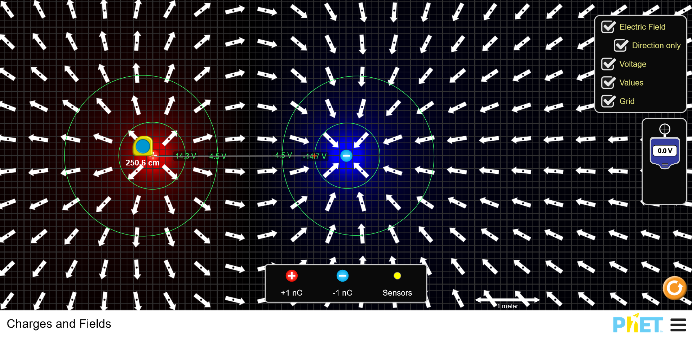

**Case 2:**

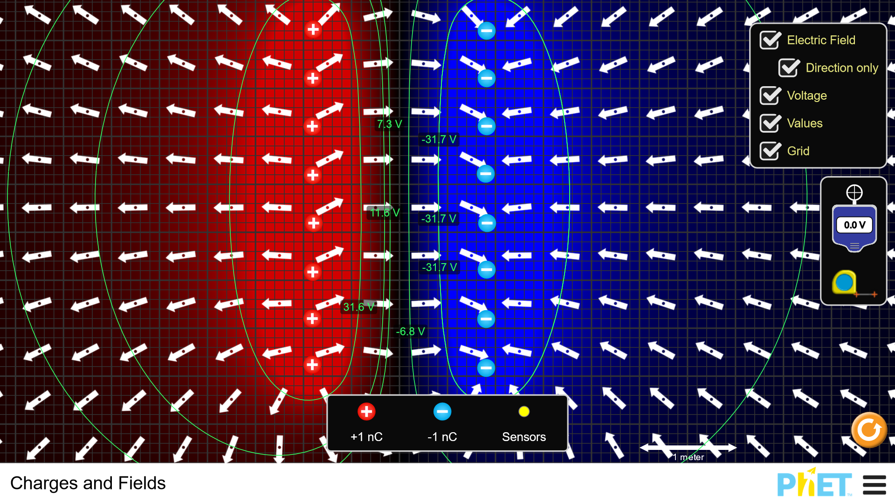

**Calculations:**

Following Case 1 Data collection, the Voltage/Potential Equation was used:

V = K(q1) / (r)

V = Voltage/Potential, K = Coulomb’s Constant: 9×10^9, q1 is the charge, and r is the distance measured.

To get the **total voltage:** you would add up all the voltage on that line measured for that distance

1 nano Coulomb is 1×10^-9

1) Calculate the total voltage of the dipole at 0.5 m right of the +1nC charge of the line that connects the charges:

(9×10^9 * 1×10^-6) / (0.5) + (9×10^9 * 1×10^-6) / (2.5) = 14.4 V

2) Calculate the total voltage of the dipole at 1.0 m right of the +1nC charge of the line that connects the charges:

(9×10^9 * 1×10^-6) / (1.0) + (9×10^9 * 1×10^-6) / (2.0) = 4.5 V

3) Calculate the total voltage of the dipole at 0.5 M left of the -1nC charge on the line that connects the charges.

(9×10^9 * 1×10^-6) / (.5) + (9×10^9 * 1×10^-6) / (2.5) = 14.4 V

4) Calculate the total voltage of the dipole at 1.0 m right of the +1nC charge of the line that connects the charges:

(9×10^9 * 1×10^-6) / (1.0) + (9×10^9 * 1×10^-6) / (2.0) = 4.5 V

**Comparison of Results:**

Calculating the percent error was done by using the following calculation, then used to calculate the percent error the Case 1 Calculations from above:



a) (13.7 – 14.4 / (13.7)) X 100 = 5.109 % error

b) (4.4 – 4.5 / (4.4)) X 100 = 2.273 % error

c) (-14.4 + 14.4 / (-14.4)) X 100 = 0 % error

d) (-4.6 + 4.5 / (4.6)) X 100 = 2.174 % error

**Conclusion:**

The objective of this lab was to measure electric field voltage/potential given certain distances from the positive or negative charges by using the PHET online simulator. The % errors gather in this lab are in the acceptable range of around 0% - 5% error range.

The theory that the equi-potential lines can be found by using a voltmeter, given that you can find points around the charge distribution that are the same voltage is proven correct in this lab. Given the results of the lab you can also establish the proper field lines as they should be perpendicular to the equi-potential lines.

**Discussion:**

Due to the low percent error from the calculations, there is no need to report what could have gone wrong through calculations, other than user error when trying to take net calculations. For this part of the calculation, it should be done as calculating the voltage as standard, then adding the charge on the negative that is also located on the line connecting the charge. Then you should be able to take the proper percent error.